Project Report

Computer Fundamental lab.

Submitted to: Sir Rehan Baig

Group members:

1.Daniyal Hassan (02-131192-060)

2.Rafi Zaman. (02-131192-084)

3.Bilal Memon. (02-131192-078)

4.M Hasnain Khanzada. (02-131192-017)

BSE-1B

TABLE OF CONTENT

1.ABSTRACT

2.INTRODUCTION

3.SOLUTION

4.TECHNOLOGIES

5.CONCLUSION

Abstract:

Our team collaborated in making of this project. What we did was creating a website on sublime and database on MS access of hospital management system. all the work was done in sequence, steps and procedure.

Introduction:

Our test was to create a website, database AND presentation on hospital system in a group . we uploaded this project on GitHub.

SOLUTION:

WEBSITE:

In the process of creating this website, we did so much hard work on navigation, padding, fonts, margin, fine scaling,

Technologies:

CSS HTML SUBLIME BOOTSTRAP

Creation of this website took a lot of our time by working along background color, with Home, About, contact us, specialist doctors, moreover a div is also used containing different sections, we tried our best. Here we will discuss the things necessary to mention in report we use a navigation bar along with a background color with home about services and contact us section when clicked on it also placed a link on it so to differentiate from a button. Moreover, a div Is also used, div is basically a container which we used to specify a certain region in our webpage, and containing different sections, all things are written under body tag so to display it on a webpage. Inline, internal, external CSS is also used where it was necessary.

WEBSITE OF HOSPITAL:

<HOME>

<!DOCTYPE html>

<html><head>

<link rel="stylesheet" href="https://stackpath.bootstrapcdn.com/bootstrap/4.4.1/css/bootstrap.min.css" integrity="sha384-Vkoo8x4CGsO3+Hhxv8T/Q5PaXtkKtu6ug5TOeNV6gBiFeWPGFN9MuhOf23Q9Ifjh" crossorigin="anonymous"> <script <link rel="stylesheet" href="https://stackpath.bootstrapcdn.com/bootstrap/4.4.1/css/bootstrap.min.css" integrity="sha384-Vkoo8x4CGsO3+Hhxv8T/Q5PaXtkKtu6ug5TOeNV6gBiFeWPGFN9MuhOf23Q9Ifjh" crossorigin="anonymous">></script>

<title>Home </title></head><body> <h1> </h1>

<h1 style="text-align: center; font-family: Times New Roman;">

Riverdale City Hospital

</h1> <nav class="navbar navbar-expand-lg navbar-dark bg-danger">

<a class="navbar-brand" href="file:///C:/Users/HP/Desktop/dani.html">Home</a>

<button class="navbar-toggler" type="button" data-toggle="collapse" data-target="#navbarSupportedContent" aria-controls="navbarSupportedContent" aria-expanded="false" aria-label="Toggle navigation">

<span class="navbar-toggler-icon"></span>

</button> <div class="collapse navbar-collapse" id="navbarSupportedContent">

<ul class="navbar-nav mr-auto"> <li class="nav-item active">

<a class="nav-link" href="file:///C:/Users/HP/Desktop/about.html">About Us</a> </li>

<li class="nav-item active"

<a class="nav-link" href="file:///C:/Users/HP/Desktop/specialist.html">Specialist Doctors</a> </li> <li class="nav-item active"> <a class="nav-link" href="file:///C:/Users/HP/Desktop/contact.html">Contact Us</a>

</li> </ul> <form class="form-inline my-2 my-lg-0">

<input class="form-control mr-sm-2" type="search" placeholder="Search" aria-label="Search">

<button class="btn btn-outline-success my-2 my-sm-0" type="submit">Search</button> </form> </div></nav><div class="card mb-3"> <div class="card-body">

<center><h5 class="card-title">Riverdale City Hospital</h5></center>

<center><p class="card-text">Riverdale City Hospital in Riverdale,America is private, not-for-profit institutions providing high quality health care. Our Hospital serve as the principal sites for clinical training for the University's Medical Colleges and Schools of Nursing and Midwifery in Riverdale,USA.</p>

<p class="card-text"><small class="text-muted"></small></p></center> </div>

</div><div class="card"> <div class="card-body">

<h5 class="card-title"></h5> <p class="card-text"></p>

<p class="card-text"><small class="text-muted"></small></p>

</div><img src="https://hospitals.aku.edu/HomeCarousel/Pic2.jpg" class="card-img-top" alt="...">

</div><h1></h1><h2> </h2><h3> </h3><h4> </h4><h5> </h5>

<h6> </h6><div class="row row-cols-1 row-cols-md-2">

<div class="col mb-4"> <div class="card">

<img src="https://www.shifa.com.pk/images/homepage/liver.jpg" class="card-img-top" alt="...">

<div class="card-body"> <h5 class="card-title">Liver Transplant</h5>

<p class="card-text">We are pioneer in launching first successful Liver Transplant in USA.One of the objectives of this program is to set-up a Center of Excellence for Liver diseases in USA. </p>

</div> </div> </div> <div class="col mb-4"> <div class="card">

<img src="https://www.shifa.com.pk/images/homepage/ortho.jpg" class="card-img-top" alt="...">

<div class="card-body">

<h5 class="card-title">Orthopedics Center</h5>

<p class="card-text">The department of orthopedics has three surgeons,is a young and vibrant team trained in Ireland and UK. Two of the surgeons are on the Specialist Register in these countries.</p> </div> </div></div> <div class="col mb-4"> <div class="card">

<img src="https://www.shifa.com.pk/images/homepage/cancer.jpg" class="card-img-top" alt="...">

<div class="card-body"> <h5 class="card-title">Cancer Center</h5>

<p class="card-text">Our cancer center provides cure for cancer with both medical oncology and radiation oncology.</p>

</div> </div> </div> <div class="col mb-4">

<div class="card"> <img src="https://www.shifa.com.pk/images/homepage/heart.jpg" class="card-img-top" alt="..."> <div class="card-body">

<h5 class="card-title">Heart Center</h5>

<p class="card-text">Riverdale Heart Center provides comprehensive services with advanced technology and personalized care to ensure diagnosis and treatment of cardiovascular services all under one roof.</p> </div> </div> </div></div>

<h1> </h1></body><h1> </h1><center><center>

<div class="container"> <div class="row">

<div class="col-md-6 col-sm-12 pull-left">

<p>© The Riverdale City Hospital</p> <a href="">Copyright </a> |

<a href="">Terms of Use</a> | <a href="">Webmail</a> </div>

<div class="col-md-6 col-sm-12"> <div class="pull-right">

<ul class="footer-social-icons icon-flat list-unstyled list-inline">

<li> <a href="#"><i class="fa fa-envelope"></i></a></li>

<li> <a href="#"><i class="fa fa-facebook"></i></a></li>

<li> <a href="#"><i class="fa fa-twitter"></i></a></li>

<li> <a href="#"><i class="fa fa-instagram"></i></a></li>

<li> <a href="#"><i class="fa fa-linkedin"></i></a></li> </ul> </div> </div> </div> </div></center></center></body></html>

Output HOME:

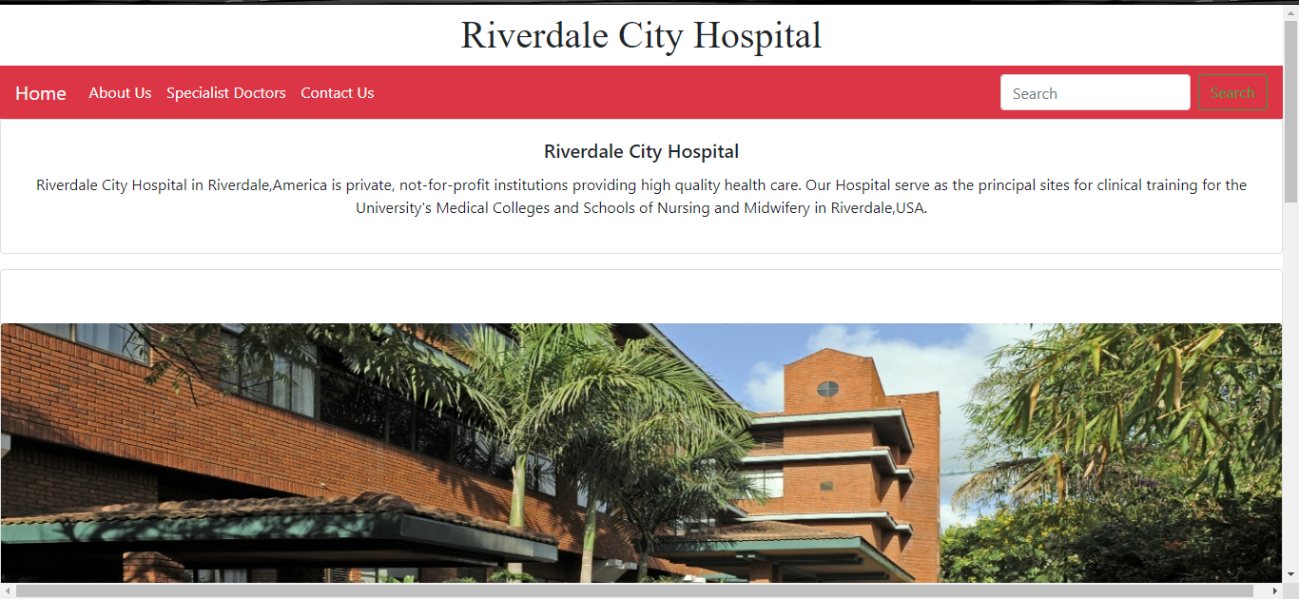

<ABOUT>

<!DOCTYPE html>

<html><head> <link rel="stylesheet" href="https://stackpath.bootstrapcdn.com/bootstrap/4.4.1/css/bootstrap.min.css" integrity="sha384-Vkoo8x4CGsO3+Hhxv8T/Q5PaXtkKtu6ug5TOeNV6gBiFeWPGFN9MuhOf23Q9Ifjh" crossorigin="anonymous">

<script link rel="stylesheet" href="https://stackpath.bootstrapcdn.com/bootstrap/4.4.1/css/bootstrap.min.css" integrity="sha384-Vkoo8x4CGsO3+Hhxv8T/Q5PaXtkKtu6ug5TOeNV6gBiFeWPGFN9MuhOf23Q9Ifjh" crossorigin="anonymous"></script>

<title>About</title></head><body> <h1> </h1> <h2>

</h2><h1 style="text-align: center; font-family: Times New Roman;">

About Us

</h1> <nav class="navbar navbar-expand-lg navbar-dark bg-danger">

<a class="navbar-brand" href="file:///C:/Users/HP/Desktop/dani.html">Home</a>

<button class="navbar-toggler" type="button" data-toggle="collapse" data-target="#navbarSupportedContent" aria-controls="navbarSupportedContent" aria-expanded="false" aria-label="Toggle navigation">

<span class="navbar-toggler-icon"></span>

</button> <div class="collapse navbar-collapse" id="navbarSupportedContent">

<ul class="navbar-nav mr-auto"> <li class="nav-item active">

<a class="nav-link" href="file:///C:/Users/HP/Desktop/about.html">About Us</a> </li>

<li class="nav-item active">

<a class="nav-link" href="file:///C:/Users/HP/Desktop/specialist.html">Specialist Doctors</a>

</li><li class="nav-item active">

<a class="nav-link" href="file:///C:/Users/HP/Desktop/contact.html">Contact Us</a> </li> </ul>

<form class="form-inline my-2 my-lg-0">

<input class="form-control mr-sm-2" type="search" placeholder="Search" aria-label="Search">

<button class="btn btn-outline-success my-2 my-sm-0" type="submit">Search</button>

</form> </div></nav><center><div class="card" style="width: 80rem;">

<img src="https://hospitals.aku.edu/HomeCarousel/homepagebanner1.jpg" class="card-img-top" alt="...">

<div class="card-body"> <h5 class="card-title">About Us</h5>

<p class="card-text">Riverdale Hospital has over two decades of experience in the healthcare sector, and is known for providing quality healthcare and valuable experience to all domestic and international patients. Our healthcare offerings are supported by a team of compassionate and dedicated medical professionals who have rich knowledge and experience in their respective domains</p> </div>

<ul class="list-group list-group-flush">

<li class="list-group-item">(724) 250-4310</li> <li class="list-group-item">(724) 225-7000</li>

<li class="list-group-item">(724) 223-3774</li> </ul> <center><div class="card-body">

<a href="#" class="card-link">Call Our helpline</a>

</div></center></div></center>

<center><center><div class="container"> <div class="row">

<div class="col-md-6 col-sm-12 pull-left"> <p>© The Riverdale City Hospital</p>

<a href="">Copyright </a> | <a href="">Terms of Use</a> | <a href="">Webmail</a> </div> <div class="col-md-6 col-sm-12"> <div class="pull-right">

<ul class="footer-social-icons icon-flat list-unstyled list-inline">

<li> <a href="#"><i class="fa fa-envelope"></i></a></li>

<li> <a href="#"><i class="fa fa-facebook"></i></a></li>

<li> <a href="#"><i class="fa fa-twitter"></i></a></li>

<li> <a href="#"><i class="fa fa-instagram"></i></a></li>

<li> <a href="#"><i class="fa fa-linkedin"></i></a></li>

</ul> </div> </div> </div> </div></center></center></body></html>

OUTPUT:

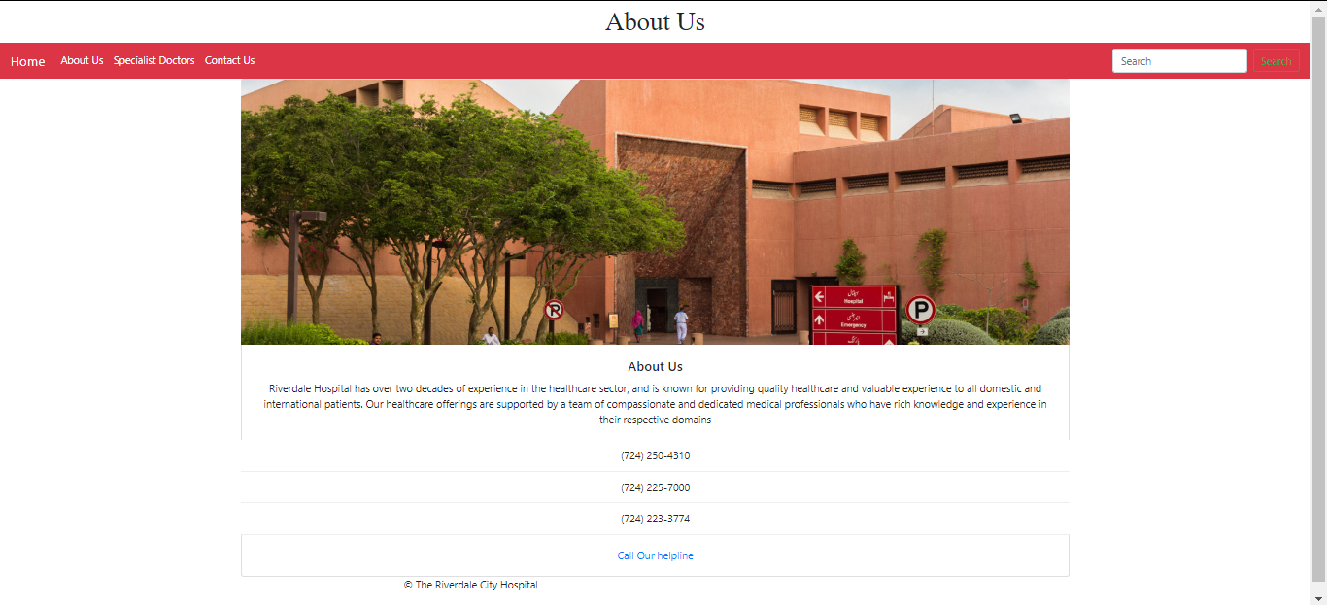

**<DOCTORS>**

<!DOCTYPE html>

<html><head>

<link rel="stylesheet" href="https://stackpath.bootstrapcdn.com/bootstrap/4.4.1/css/bootstrap.min.css" integrity="sha384-Vkoo8x4CGsO3+Hhxv8T/Q5PaXtkKtu6ug5TOeNV6gBiFeWPGFN9MuhOf23Q9Ifjh" crossorigin="anonymous">

<script <link rel="stylesheet" href="https://stackpath.bootstrapcdn.com/bootstrap/4.4.1/css/bootstrap.min.css" integrity="sha384-Vkoo8x4CGsO3+Hhxv8T/Q5PaXtkKtu6ug5TOeNV6gBiFeWPGFN9MuhOf23Q9Ifjh" crossorigin="anonymous">></script>

<title> Specialist Doctor</title></head><body>

<h1> <h1> </h1>

<h1 style="text-align: center; font-family: Times New Roman;"> Specialist Doctors </h1>

</h1> <nav class="navbar navbar-expand-lg navbar-dark bg-danger">

<a class="navbar-brand" href="file:///C:/Users/HP/Desktop/dani.html">Home</a>

<button class="navbar-toggler" type="button" data-toggle="collapse" data-target="#navbarSupportedContent" aria-controls="navbarSupportedContent" aria-expanded="false" aria-label="Toggle navigation">

<span class="navbar-toggler-icon"></span> </button>

<div class="collapse navbar-collapse" id="navbarSupportedContent">

<ul class="navbar-nav mr-auto"> <li class="nav-item active">

<a class="nav-link" href="file:///C:/Users/HP/Desktop/about.html">About Us</a>

</li> <li class="nav-item active"> <a class="nav-link" href="file:///C:/Users/HP/Desktop/specialist.html">Specialist Doctors</a> </li> <li class="nav-item active">

<a class="nav-link" href="file:///C:/Users/HP/Desktop/contact.html">Contact Us</a>

</li> </ul> <form class="form-inline my-2 my-lg-0">

<input class="form-control mr-sm-2" type="search" placeholder="Search" aria-label="Search">

<button class="btn btn-outline-success my-2 my-sm-0" type="submit">Search</button> </form> </div></nav><h1> </h1><center><div class="card" style="width: 30rem;" class="center";>

<img src="https://pbs.twimg.com/media/C0QqTvpXcAMpXCG.jpg" class="card-img-top" alt="...">

<div class="card-body"> <h5 class="card-title">Dr.John Watson </h5>

<p class="card-text"> Dr.John Watson is a specialist Orthopedic.He has also a served as an army doctor.</p>

<p class="card-text"><small class="text-muted"></small></p> </div></div></center><h1> </h1><center>

<div class="card" style="width: 30rem;" class="center";>

<img src="https://i.pinimg.com/originals/f3/87/e1/f387e11f493953e9ed3b4be72c96cced.jpg" class="card-img-top" alt="...">

<div class="card-body"> <h5 class="card-title">Dr.Sherlock Holmes </h5>

<p class="card-text">Dr.Holmes is highly qualified psychiatrist and has 20 years of experience.</p>

<p class="card-text"><small class="text-muted"></small></p> </div></div></center>

<center><div class="card" style="width: 30rem;" class="center";>

<img src="https://images.justwatch.com/backdrop/15073904/s1440/munna-bhai-m-b-b-s" class="card-img-top" alt="...">

<div class="card-body"> <h5 class="card-title">Dr.Murli Parsaat Sharma</h5>

<p class="card-text">Dr.Murli Parsaat sharma a.k.a Munna Bhai is a specialist in all fields, he has his own hospital and also practice as a visitor in Riverdale City Hospital.</p>

<p class="card-text"><small class="text-muted"></small></p> </div></div></center><center>

<div class="card" style="width: 30rem;" class="center";>

<img src="https://dooleyonline.typepad.com/.a/6a00e551a4e0f3883301a511bff21e970c-800wi" class="card-img-top" alt="...">

<div class="card-body"> <h5 class="card-title">Dr.Ghongroo Seth</h5>

<p class="card-text">Dr.Ghongroo Seth is a very famous and widely known surgeon who practice and doesnot take any money from poor people.</p>

<p class="card-text"><small class="text-muted"></small></p>

</div></div></center><center><center><div class="container"> <div class="row">

<div class="col-md-6 col-sm-12 pull-left"> <p>© The Riverdale City Hospital</p>

<a href="">Copyright </a> | <a href="">Terms of Use</a> | <a href="">Webmail</a>

</div> <div class="col-md-6 col-sm-12"> <div class="pull-right">

<ul class="footer-social-icons icon-flat list-unstyled list-inline">

<li> <a href="#"><i class="fa fa-envelope"></i></a></li>

<li> <a href="#"><i class="fa fa-facebook"></i></a></li>

<li> <a href="#"><i class="fa fa-twitter"></i></a></li>

<li> <a href="#"><i class="fa fa-instagram"></i></a></li>

<li> <a href="#"><i class="fa fa-linkedin"></i></a></li> </ul></div> </div> </div> </div></center></center></body></html>

OUTPUT:

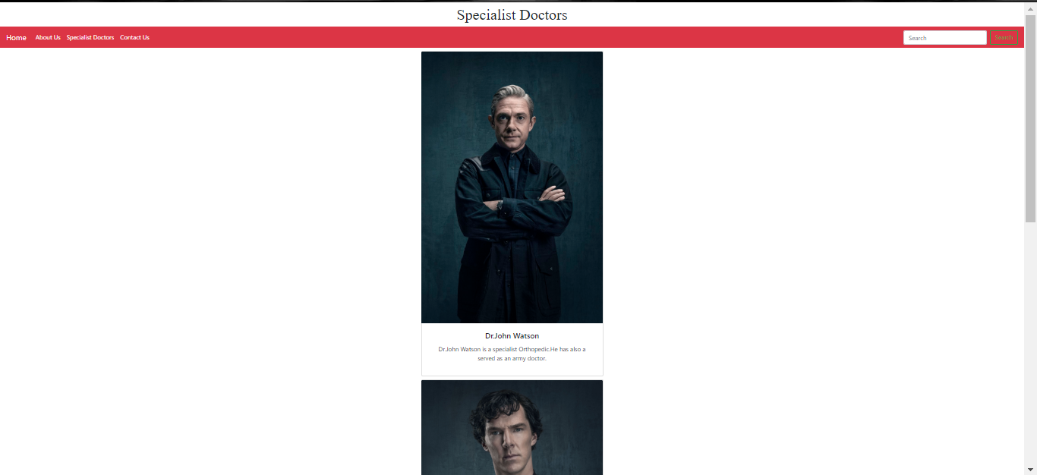

<CONTACT US>

<!DOCTYPE html>

<html>

<head> <link rel="stylesheet" href="https://stackpath.bootstrapcdn.com/bootstrap/4.4.1/css/bootstrap.min.css" integrity="sha384-Vkoo8x4CGsO3+Hhxv8T/Q5PaXtkKtu6ug5TOeNV6gBiFeWPGFN9MuhOf23Q9Ifjh" crossorigin="anonymous">

<script link rel="stylesheet" href="https://stackpath.bootstrapcdn.com/bootstrap/4.4.1/css/bootstrap.min.css" integrity="sha384-Vkoo8x4CGsO3+Hhxv8T/Q5PaXtkKtu6ug5TOeNV6gBiFeWPGFN9MuhOf23Q9Ifjh" crossorigin="anonymous">></script>

<title>Contact Us</title></head><body> <h1> <h1> </h1>

<h1 style="text-align: center; font-family: Times New Roman;">

Contact Us </h1></h1>

<nav class="navbar navbar-expand-lg navbar-dark bg-danger">

<a class="navbar-brand" href="file:///C:/Users/HP/Desktop/dani.html">Home</a>

<button class="navbar-toggler" type="button" data-toggle="collapse" data-target="#navbarSupportedContent" aria-controls="navbarSupportedContent" aria-expanded="false" aria-label="Toggle navigation">

<span class="navbar-toggler-icon"></span> </button>

<div class="collapse navbar-collapse" id="navbarSupportedContent">

<ul class="navbar-nav mr-auto">

<li class="nav-item active">

<a class="nav-link" href="file:///C:/Users/HP/Desktop/about.html">About Us</a>

</li> <li class="nav-item active">

<a class="nav-link" href="file:///C:/Users/HP/Desktop/specialist.html">Specialist Doctors</a>

</li> <li class="nav-item active">

<a class="nav-link" href=" file:///C:/Users/HP/Desktop/contact.html">Contact Us</a> </li> </ul>

<form class="form-inline my-2 my-lg-0">

<input class="form-control mr-sm-2" type="search" placeholder="Search" aria-label="Search">

<button class="btn btn-outline-success my-2 my-sm-0" type="submit">Search</button>

</form> </div></nav><h1> </h1><center>

<h5 style="text-align: center; font-family: Times New Roman;" >

<h1>Riverdale City Hospital Phone Numbers</h1><h1> </h1><h5><ul class="list-group">

<li class="list-group-item">WHS Physician Referral Line (724) 250-4310</li>

<li class="list-group-item">WHS Washington Hospital (724) 225-7000</li>

<li class="list-group-item">Hospital Billing Questions (724) 223-3034</li>

<li class="list-group-item">WPG Billing Questions (724) 229-1926</li>

<li class="list-group-item">Case Management (724) 223-3291</li>

<li class="list-group-item">WHS Greene (724) 627-3101</li>

<li class="list-group-item">WHS Community Relations (724) 223-3774</li>

<li class="list-group-item">WHS Foundation (724) 223-3875</li></ul></h5>

</h5></center></body><center><center><div class="container"> <div class="row">

<div class="col-md-6 col-sm-12 pull-left">

<p>© The Riverdale City Hospital</p> <a href="">Copyright </a> | <a href="">Terms of Use</a> | <a href="">Webmail</a> </div>

<div class="col-md-6 col-sm-12"> <div class="pull-right"> <ul class="footer-social-icons icon-flat list-unstyled list-inline">

<li> <a href="#"><i class="fa fa-envelope"></i></a></li>

<li> <a href="#"><i class="fa fa-facebook"></i></a></li>

<li> <a href="#"><i class="fa fa-twitter"></i></a></li>

<li> <a href="#"><i class="fa fa-instagram"></i></a></li>

<li> <a href="#"><i class="fa fa-linkedin"></i></a></li> </ul> </div> </div> </div> </div></center></center></html>

OUTPUT:

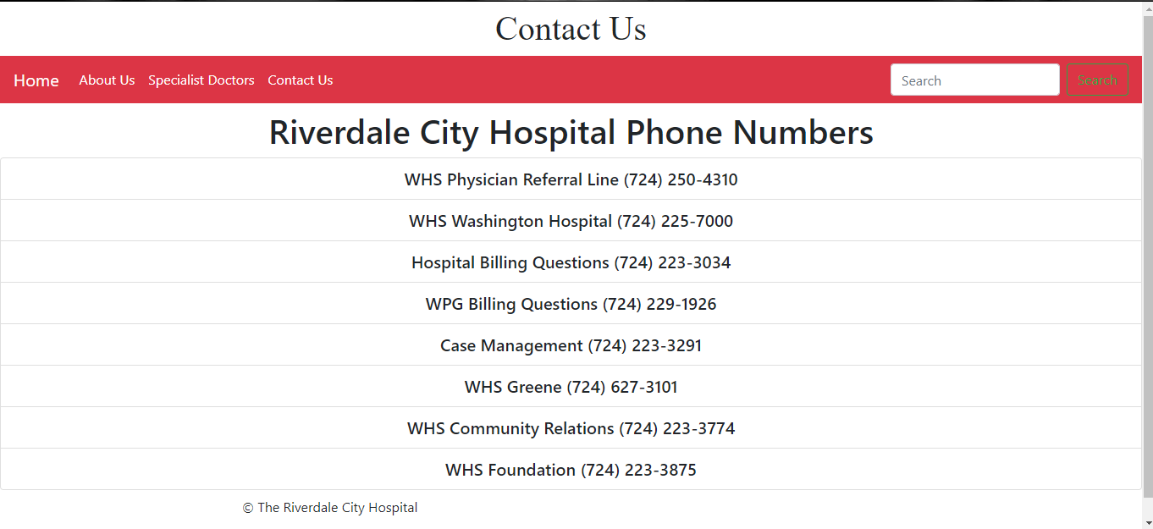

**MS ACCESS DATABASE**

In Microsoft access database we first go through all necessary thing which we need to maintain our data.

**HOSPITAL RECORD (DATA BASE)**

**PATIENT RECORD:**

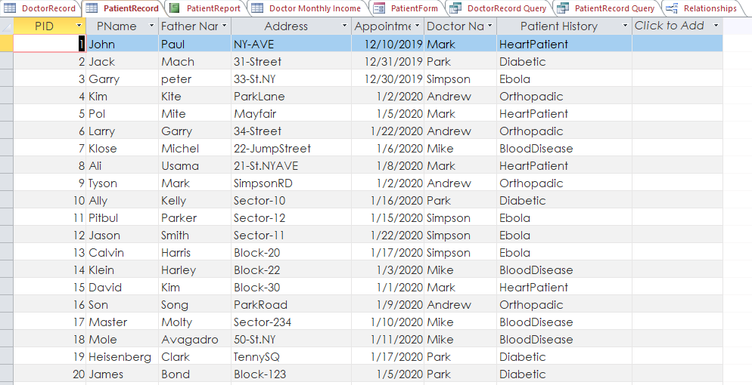

DOCTOR RECORD:

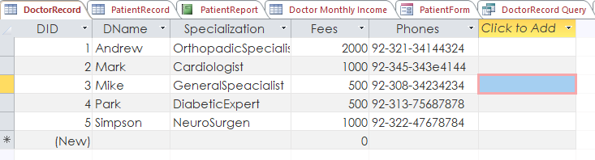

DOCTOR MONTHLY INCOME:

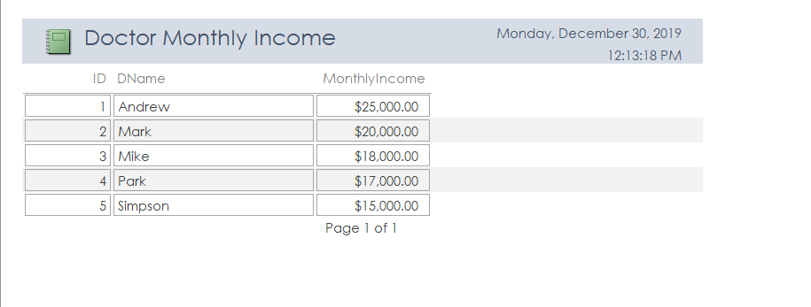

DOCTOR RECORD QUERY:

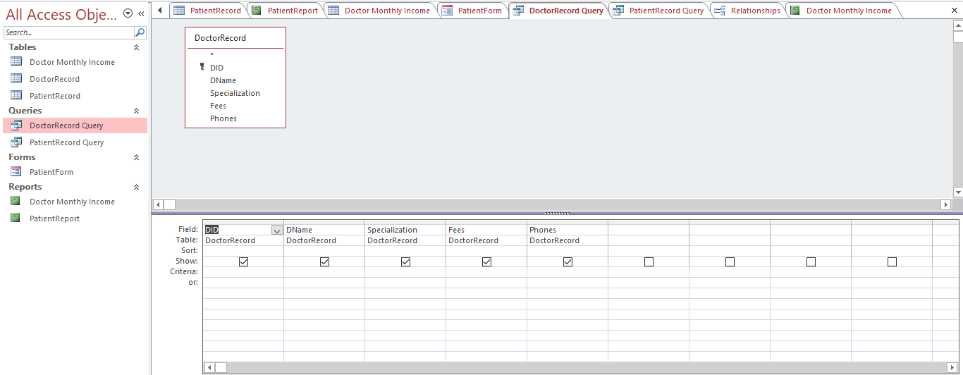

PATIENT REPORT:

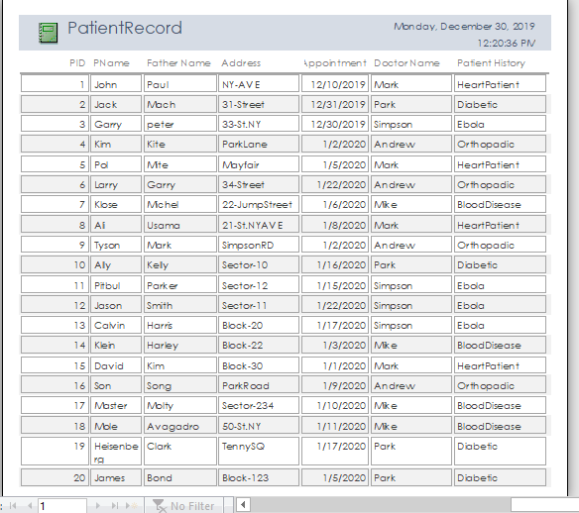

PATIENT RECORD QUERY:

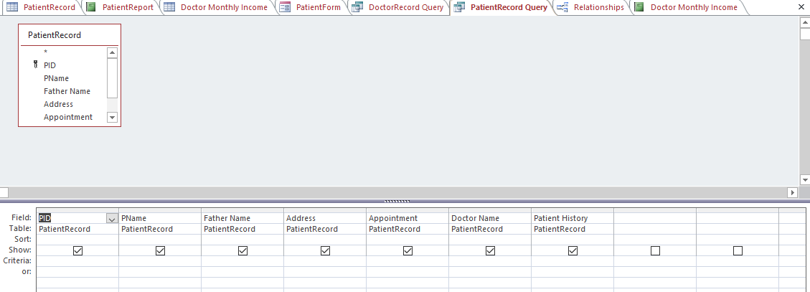

RELATIONSHIP:

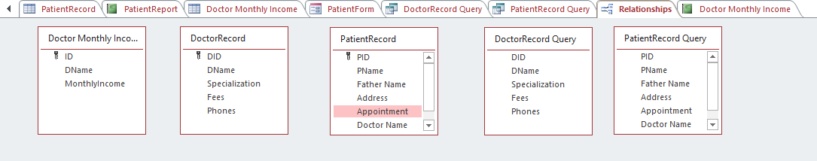

PATIENT FORM:

